Chapter 8, Problem 25.

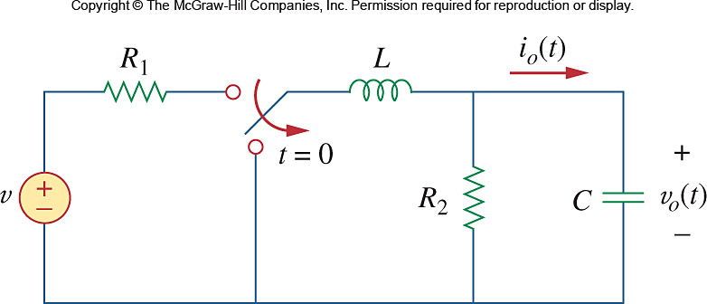
Using Fig. 8.78, design a problem to help other students better understand source-free RLC circuits.

Figure 8.78
For Prob. 8.25.

